* Create a report in Microsoft Word, and answer the following questions:
  + Given the provided data, what are three conclusions that we can draw about crowdfunding campaigns?

Given the data provided, the campaign's projects are 56.5% to be successful than fail ( 36.4%). The highest success categories are theater, technology, music, film& Video. The lowest success categories are food, games, and publishing.

As the data provided. We can see the successful, failed, and canceled rates for each subcategory. As we can see the success rate and the failed rate were almost the same. But we can conclude that plays are very popular, they contain the most successful, failed, and canceled in it.

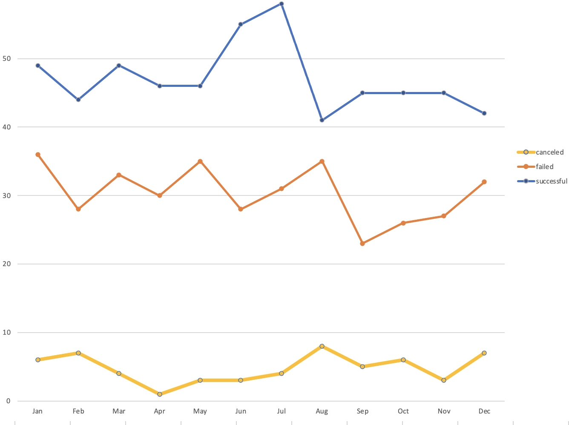

As the data provided. From mid-July to August success and failed were slight decreased.

* + What are some limitations of this dataset?

This dataset was not large enough to represent the category of the campaigns. however, if there is more information for categories showing which periods of time do better and worse. That will help us better analyze the data.

* + What are some other possible tables and/or graphs that we could create, and what additional value would they provide?

1. We can create a graph with and without the category “plays”, because “plays” is the most popular category and contained the most successful and unsuccessful.
2. Displays and tables that exclude significant funding goal outliers.